Languages in the USA
The United States is a linguistically diverse country, though English is the dominant language. Here are the most spoken languages:
1. English – The national language, used in government, business, education, and daily life.
2. Spanish – The second most spoken language, especially in states with large Hispanic populations like California, Texas, and Florida.
3. Chinese (including Cantonese and Mandarin) – Spoken by Chinese-American communities, particularly in cities like San Francisco, Los Angeles, and New York.
4. Tagalog (Filipino) – Spoken by many Filipino-Americans, especially in California and Hawaii.
5. Vietnamese – Spoken in many Vietnamese-American communities, like California and Texas.
6. French – Spoken by some communities in Louisiana and parts of the Northeast, as well as Haitian Creole speakers in Florida.
7. Arabic – Spoken by Arab-American communities in various parts of the country, especially Michigan.
8. Korean – Spoken by Korean-American communities, especially in California and New York.
9. German – Historically, it was more widely spoken, but today it persists in smaller areas, particularly among Amish and Mennonite communities.
10. Russian – Spoken by Russian-speaking immigrants in cities like New York, Los Angeles, and Chicago.
There are also many Native American languages spoken by Indigenous groups, though many are endangered. The USA is home to speakers of over 350 languages, reflecting the country's multicultural composition.
Portuguese is also spoken in the USA, primarily by communities of immigrants from Portugal and Brazil. The majority of Portuguese speakers come from Brazil. The largest concentrations of Portuguese speakers can be found in:
1. Massachusetts – This state has one of the largest Portuguese-speaking populations, particularly in cities like Fall River, New Bedford, and Somerville. Many of the people are descendents of people from Portuguese and Cape Verde.
2. Rhode Island – This state has a significant Portuguese-speaking population, particularly in the city of Providence. Portuguese immigrants have had a long history in Rhode Island.
3. Connecticut – Cities like Bridgeport, Danbury, and Waterbury have notable Portuguese and Brazilian communities.
4. New Jersey – The city of Newark, especially the Ironbound neighborhood, has a large Portuguese-speaking community, as well as Brazilian immigrants.
5. California – The San Francisco Bay Area and parts of Southern California, especially in Los Angeles, have large Brazilian communities.
6. Florida – There are many Portuguese speakers, particularly Brazilians, in cities like Miami and Orlando. These are areas popular among Brazilian immigrants and tourists.
7. New York – New York City and nearby areas, such as Mount Vernon, have communities of Portuguese and Brazilian immigrants.

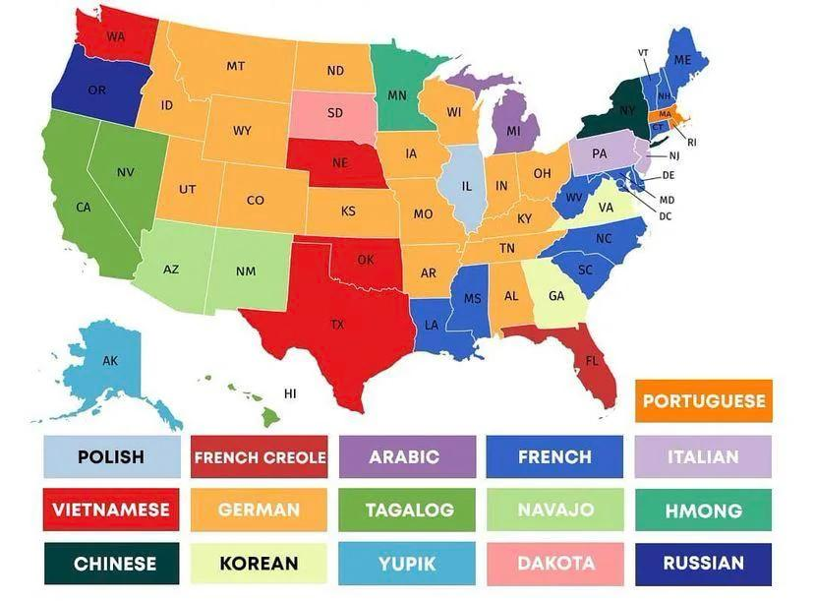

Most spoken languages, other than English

